The iconic Australian sporting event the Tom Quilty Gold Cup is coming to Western Australia.
Could your organisation profit from promotion and advertising of your products and/or services whilst also benefit from advertising your community involvement and support of this National event?
Does your organisation want to embrace the true Australian Community Spirit, the endurance riding motto “To Complete is to Win”, and Australian History that is the Tom Quilty Gold Cup Endurance Ride?
Known internationally, the Tom Quilty Gold Cup is one of the most recognised equestrian events in Australia. Competitors come from across Australia and the globe to participate in the prestigious event in every capacity, including: riders; volunteers; officials; and spectators.
The Tom Quilty Gold Cup rotates between the states of Australia and will return to Western Australia in 2020 for the first time in 6 years. The Tom Quilty Gold Cup will be hosted by the Western Australian Endurance Riders Association (WAERA) and will be held in Collie in the South West of WA. Click here for more info about Collie.
This presents a fantastic and unique opportunity to advertise nationally your support of a very large community event and to embrace the true Australian Spirit that the Tom Quilty Gold Cup embodies. Click here to learn more about the History of the Quilty.
Extensive Advertising of this event has already begun, with the Event Facebook page operational, website launched, initial newspaper articles distributed, and a team of advertising crew ready to promote all sponsors and supporters of the event.
WAERA offers you the opportunity to utilise this National event whilst it is in Western Australia. We present an array of sponsorship packages available to cater for all organisations’ advertising needs, both large and small, to promote your company, products, services and also demonstrate your community involvement and support.
We welcome any enquiries you have about the Tom Quilty Gold Cup in Collie in 2020 and look forward to discussing with you how WAERA can help to promote your organisation at this event.
Yours faithfully,
Jane Radny 0419 198 976 - Rosanne Pimm 0428 176 817
Sponsorship Portfolio Team 2020 Tom Quilty Gold Cup, Collie WA

Sponsorship Packages – 2020 Tom Quilty Gold Cup – Western Australia
Are you a large organisation looking to support a community event and promote your sense of community and support?
Are you a business looking to promote your products and/or services?
Would you like maximum exposure for your organisation prior to, during and after the event?
Would you like naming rights to a specific area for maximum exposure?

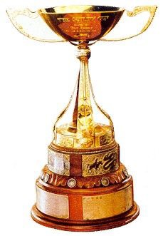

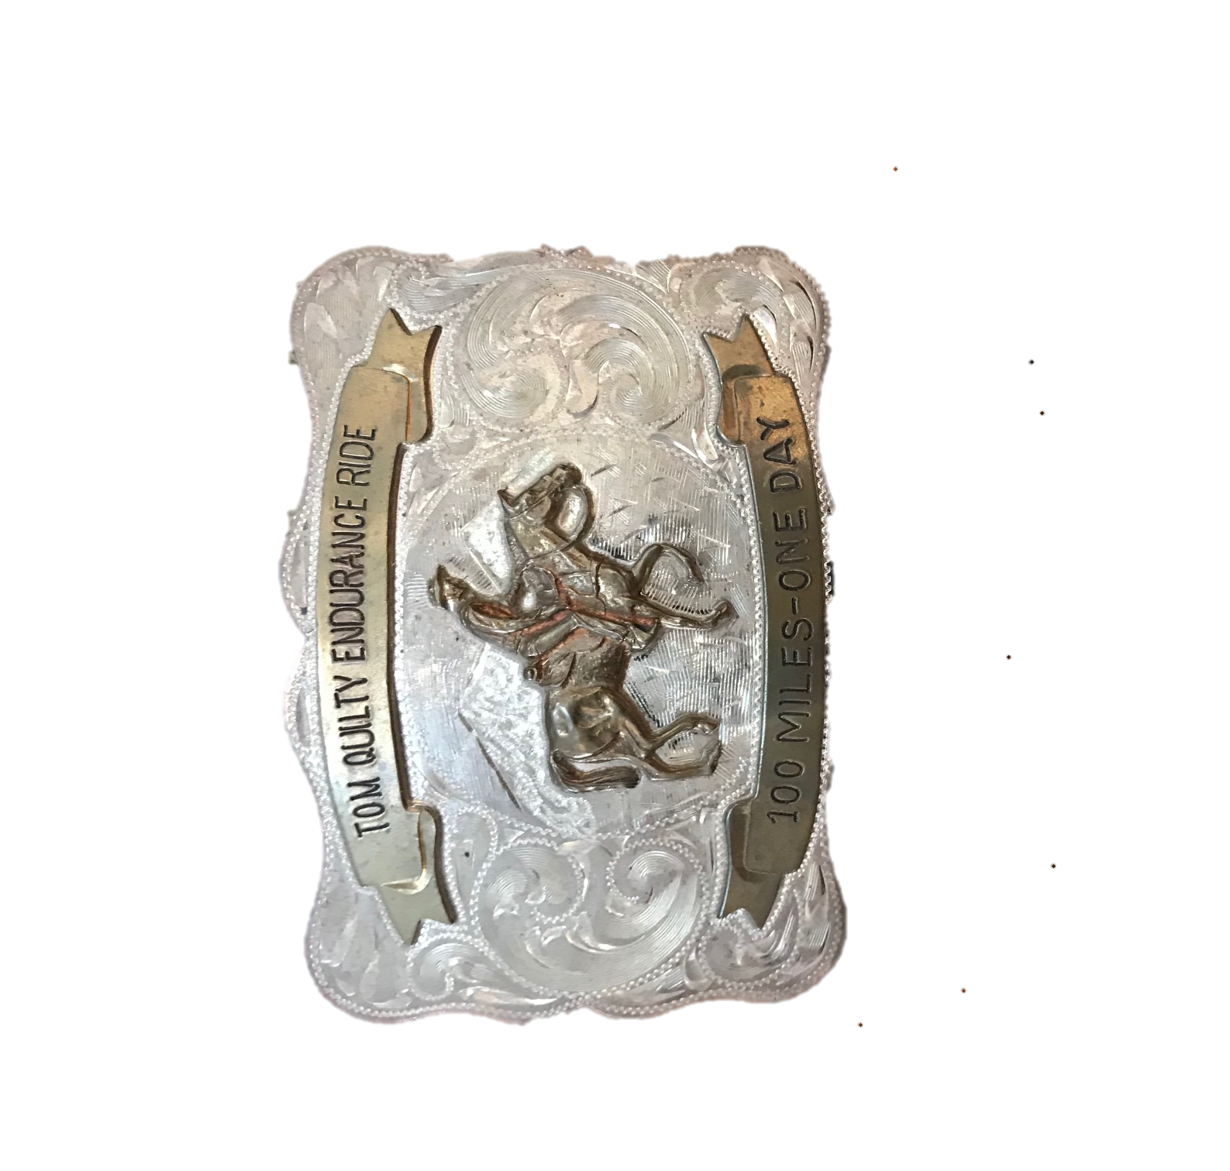

The Tom Quilty Gold Cup awarded to the winner of the event.

Are you a small business looking to promote your services or an individual looking to support the event but don’t have a lot to spend on sponsorship?
Maybe you would like to offer your support through volunteering at the event?
Every small amount of sponsorship or support helps us to create a wonderful Tom Quilty event.

The Tom Quilty Buckle awarded to all completers of the event.

Here are a few suggests available for sponsorship packages. Alternatively, we can tailor a plan to suit your individual needs.

Major Sponsor - Vet Ring Sponsorship

As a major sponsor you will receive naming rights to the Vet Ring at the Tom Quilty Gold Cup event. The Vet Ring is the hub of the Tom Quilty as horses pass through numerous times for veterinary inspections throughout the event. It is a space that attracts the majority of spectators during the event.
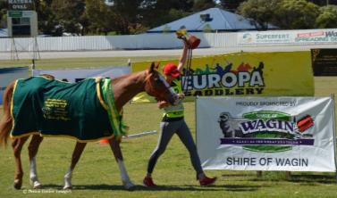
- Banners displaying your organisation’s name in the designated area (if provided).
- Regular announcements broadcast on PA system referring to your organisation’s designated named area i.e. “Star Enterprises Vet Ring”.
- Your organisation’s name will be embroidered on a Best Conditioned Award Kersey Wool Rug for one of the ride divisions. The Best Conditioned Award is valued as one of the most prestigious awards to win for any endurance ride.
- As a major sponsor you will be acknowledged and thanked as part of any documentary of film product made using media technology.
- Your organisation’s name and logo will be printed on the start/finish banner, which is a prominent position for photos and videos of participants.
- Prime camping site for sponsors that are competing at the event.
- Prime display in the entertainment and catering area during the event to provide information about your organisation, product and/or services.
- Your organisation’s logo on advertising and promotion of the event.
- Extensive promotion on Tom Quilty Gold Cup Website and Facebook page.
- Free full-page colour advertisement (inside cover or back cover) within the Tom Quilty Gold Cup Event magazine/Endurance Yearbook.
- Sponsor slogan and short paragraph description to be broadcast over the PA system at regular intervals during the event.
- Free entry for 8 sponsor representatives to attend the Quilty Lunch and Presentations after the event.
- 8 Tom Quilty Gold Cup Event magazines/Endurance Yearbook.
- Sponsorship acknowledgement at Pre-ride Briefing and at all presentations.
- Sponsors products, promotion material, and information to be distributed to all riders, volunteers, vets, officials and spectators (if provided).

Sponsorship Sold

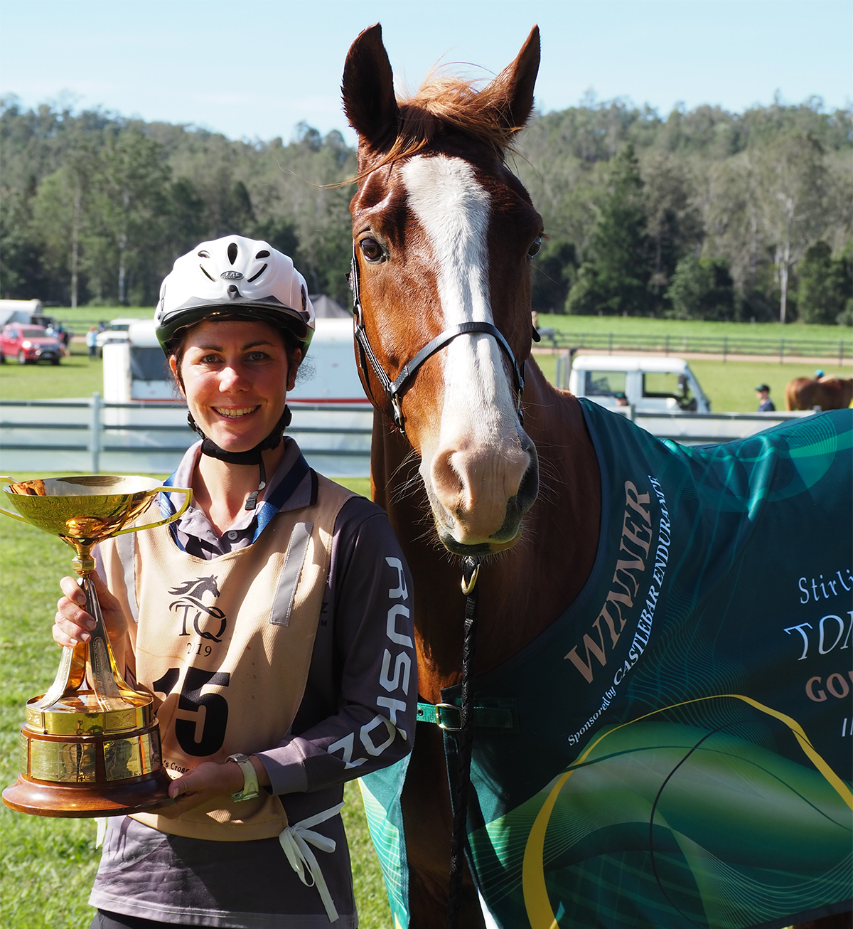

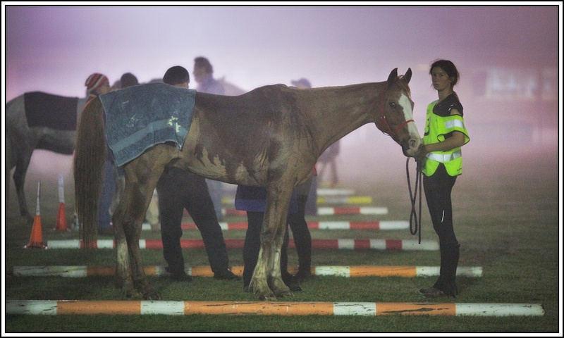

Vet Ring Sponsorship Package $20,000 (amount and/or extra promotion can be negotiated)

Major Sponsor - Entertainment & Catering Sponsorship

As a major sponsor you will receive naming rights to the Entertainment & Catering Area at the Tom Quilty Gold Cup event. Your sponsorship will contribute to the hiring of a 15m x 30m marquee, complete with lights, dance floor and partition walls. In addition, your sponsorship will include the hiring of giant games including Jenga, Connect 4 and Noughts and Crosses. This will be the hub of the Australian Endurance Riders’ Associating Annual Awards night, Pre-ride Briefing, presentations, gatherings for meals, socialising and where the trade stalls will be located.
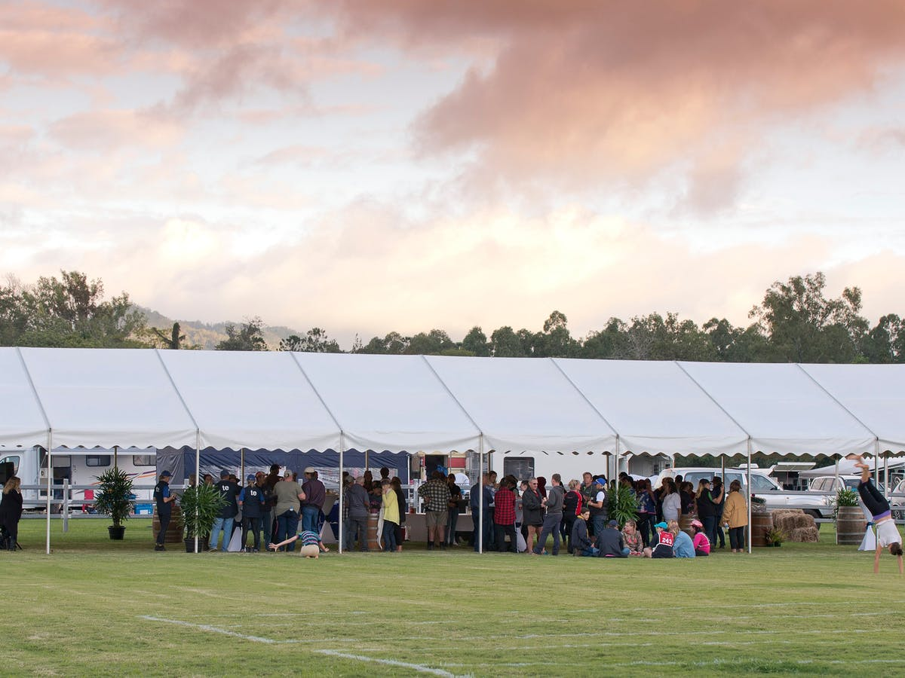
- Numerous banners with your organisation’s name displayed in designated area (if provided).
- Regular announcements broadcast on PA system referring to your organisation’s designated named area i.e. “Star Enterprises Entertainment & Catering Area”.
- Your organisation’s name will be embroidered on a Best Conditioned Award Kersey Wool Rug for one of the ride divisions. The Best Conditioned Award is valued as one of the most prestigious awards to win for any endurance ride.
- As a major sponsor you will be acknowledged and thanked as part of any documentary of film product made using media technology.
- Your organisation’s name and logo will be printed on the start/finish banner, which is a prominent position for photos and videos of participants.
- Your organisation’s logo on advertising and promotion of the event.
- Prime camping site for sponsors that are competing at the event.
- Prime display in the entertainment and catering area during the event to provide information about your organisation, product and/or services.
- Extensive promotion on Tom Quilty Gold Cup Website and Facebook page.
- Free full-page colour advertisement (inside cover or back cover) within the Tom Quilty Gold Cup Event magazine/Endurance Yearbook.
- Sponsor slogan and short paragraph description to be broadcast over the PA system at regular intervals during the event.
- Free entry for 8 sponsor representatives to attend the Quilty Lunch and Presentations after the event.
- 8 Tom Quilty Gold Cup Event magazines/Endurance Yearbook.
- Sponsorship acknowledgement at Pre-ride Briefing and at all presentations.
- Sponsors products, promotion material, and information to be distributed to all riders, volunteers, vets, officials and spectators (if provided).

Sponsorship Sold

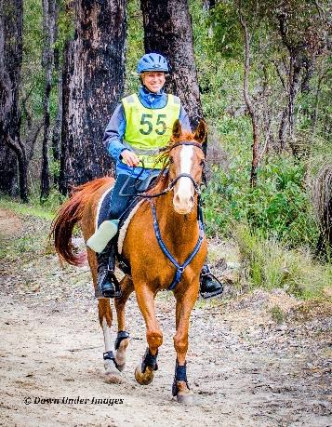

Entertainment & Catering Area Sponsorship Package $15,000 (amount and/or extra promotion can be negotiated)

Major Sponsor - Camping Area Sponsorship

As a major sponsor you will receive naming rights to the Rider Camping Area at the Tom Quilty Gold Cup event. This area is estimated to have over 100 horses and over 300 people camping in it across the event.
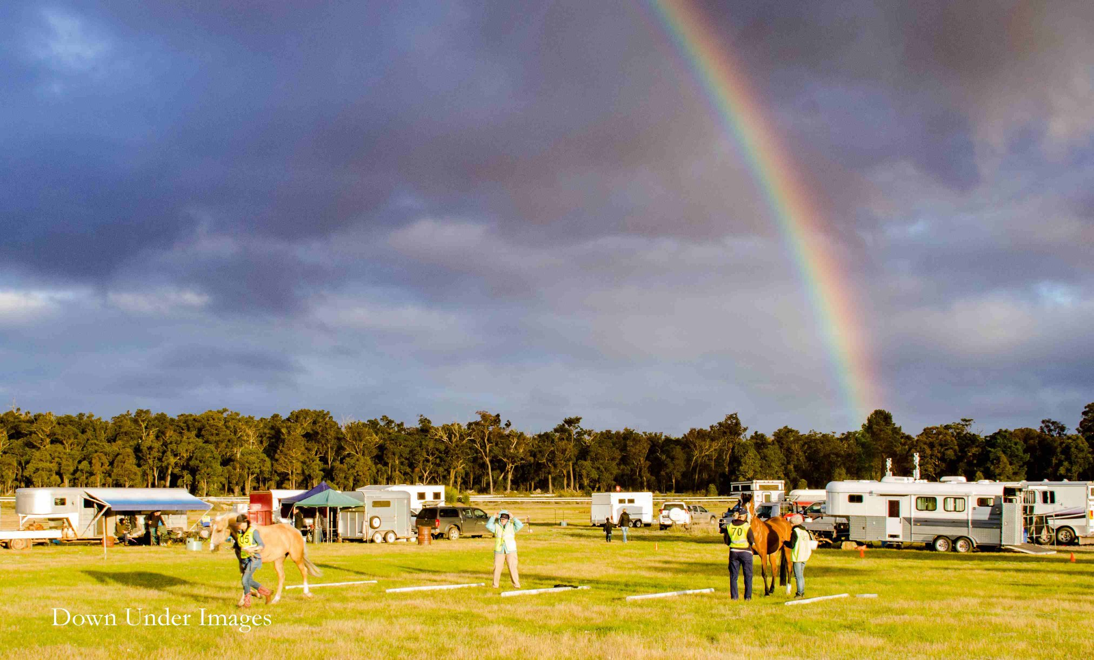
- Banners with your organisation’s name displayed in the designated area (if provided).
- Regular announcements broadcast on PA system referring to your organisation’s designated named area i.e. “Star Enterprises Camping Area”.
- As a major sponsor you will be acknowledged and thanked as part of any documentary of film product made using media technology.
- A display in the entertainment and catering area during the event to provide information about your organisation, products and/or services.
- Your organisation’s name and logo will be printed on the start/finish banner, which is a prominent position for photos and videos of participants.
- Your organisation’s logo on advertising and promotion of the event.
- Extensive promotion on Tom Quilty Gold Cup Website and Facebook page.
- Free full-page colour advertisement within the Tom Quilty Gold Cup Event magazine/Endurance Yearbook.
- Sponsor slogan and short paragraph description to be broadcast over the PA system at regular intervals during the event.
- Free entry for 4 sponsor representatives to attend the Quilty Lunch and Presentations after the event.
- 4 Tom Quilty Gold Cup Event magazines/Endurance Yearbook.
- Sponsorship acknowledgement at Pre-ride Briefing and at all presentations.
- Sponsors products, promotion material, and information to be distributed to all riders, volunteers, vets, officials and spectators (if provided).

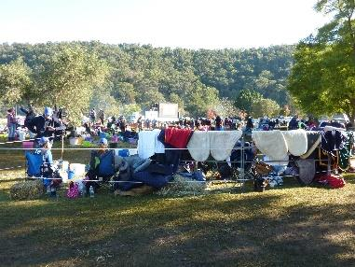

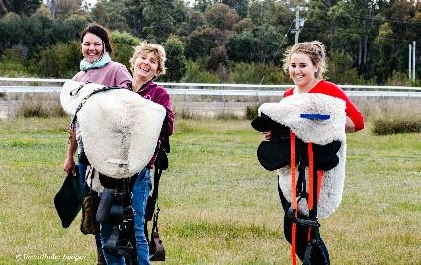

Camping Area Sponsorship Package $10,000 (amount and/or extra promotion can be negotiated)

Horse Hospital Sponsorship

To maintain the highest horse welfare standards, a horse hospital will be erected at the ride venue. This hospital will treat any horses in need of expert veterinary attention. The sponsor of this package will have naming rights for the Horse Hospital and fund the items necessary for the full functioning of this facility. These items include a 10m x 9m marquee, internal yards, heaters, ropes and pulleys, disinfectant, tables and chairs, sawdust bedding, water and feed buckets, towels, rugs, feed, and refreshments for vets and owners/riders.
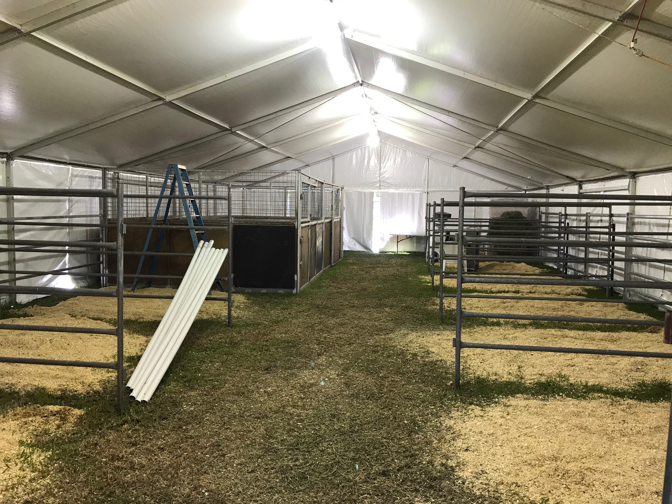
- Banners with your organisation’s name displayed in the designated area (if provided).
- Regular announcements broadcast on PA system referring to your organisation’s designated named area i.e. “Star Enterprises Horse Hospital”.
- A display in the entertainment and catering area during the event to provide information about your organisation, products and/or services.
- Extensive promotion on Tom Quilty Gold Cup Website and Facebook page.
- Free half-page colour advertisement within the Tom Quilty Gold Cup Event magazine/Endurance Yearbook.
- Sponsor slogan and short paragraph description to be broadcast over the PA system at regular intervals during the event.
- Free entry for 2 sponsor representatives to attend the Quilty Lunch and Presentations after the event.
- 2 Tom Quilty Gold Cup Event magazines/Endurance Yearbook.
- Sponsorship acknowledgement at Pre-ride Briefing and at all presentations.
- Sponsors products, promotion material, and information to be distributed to all riders, volunteers, vets, officials and spectators (if provided).

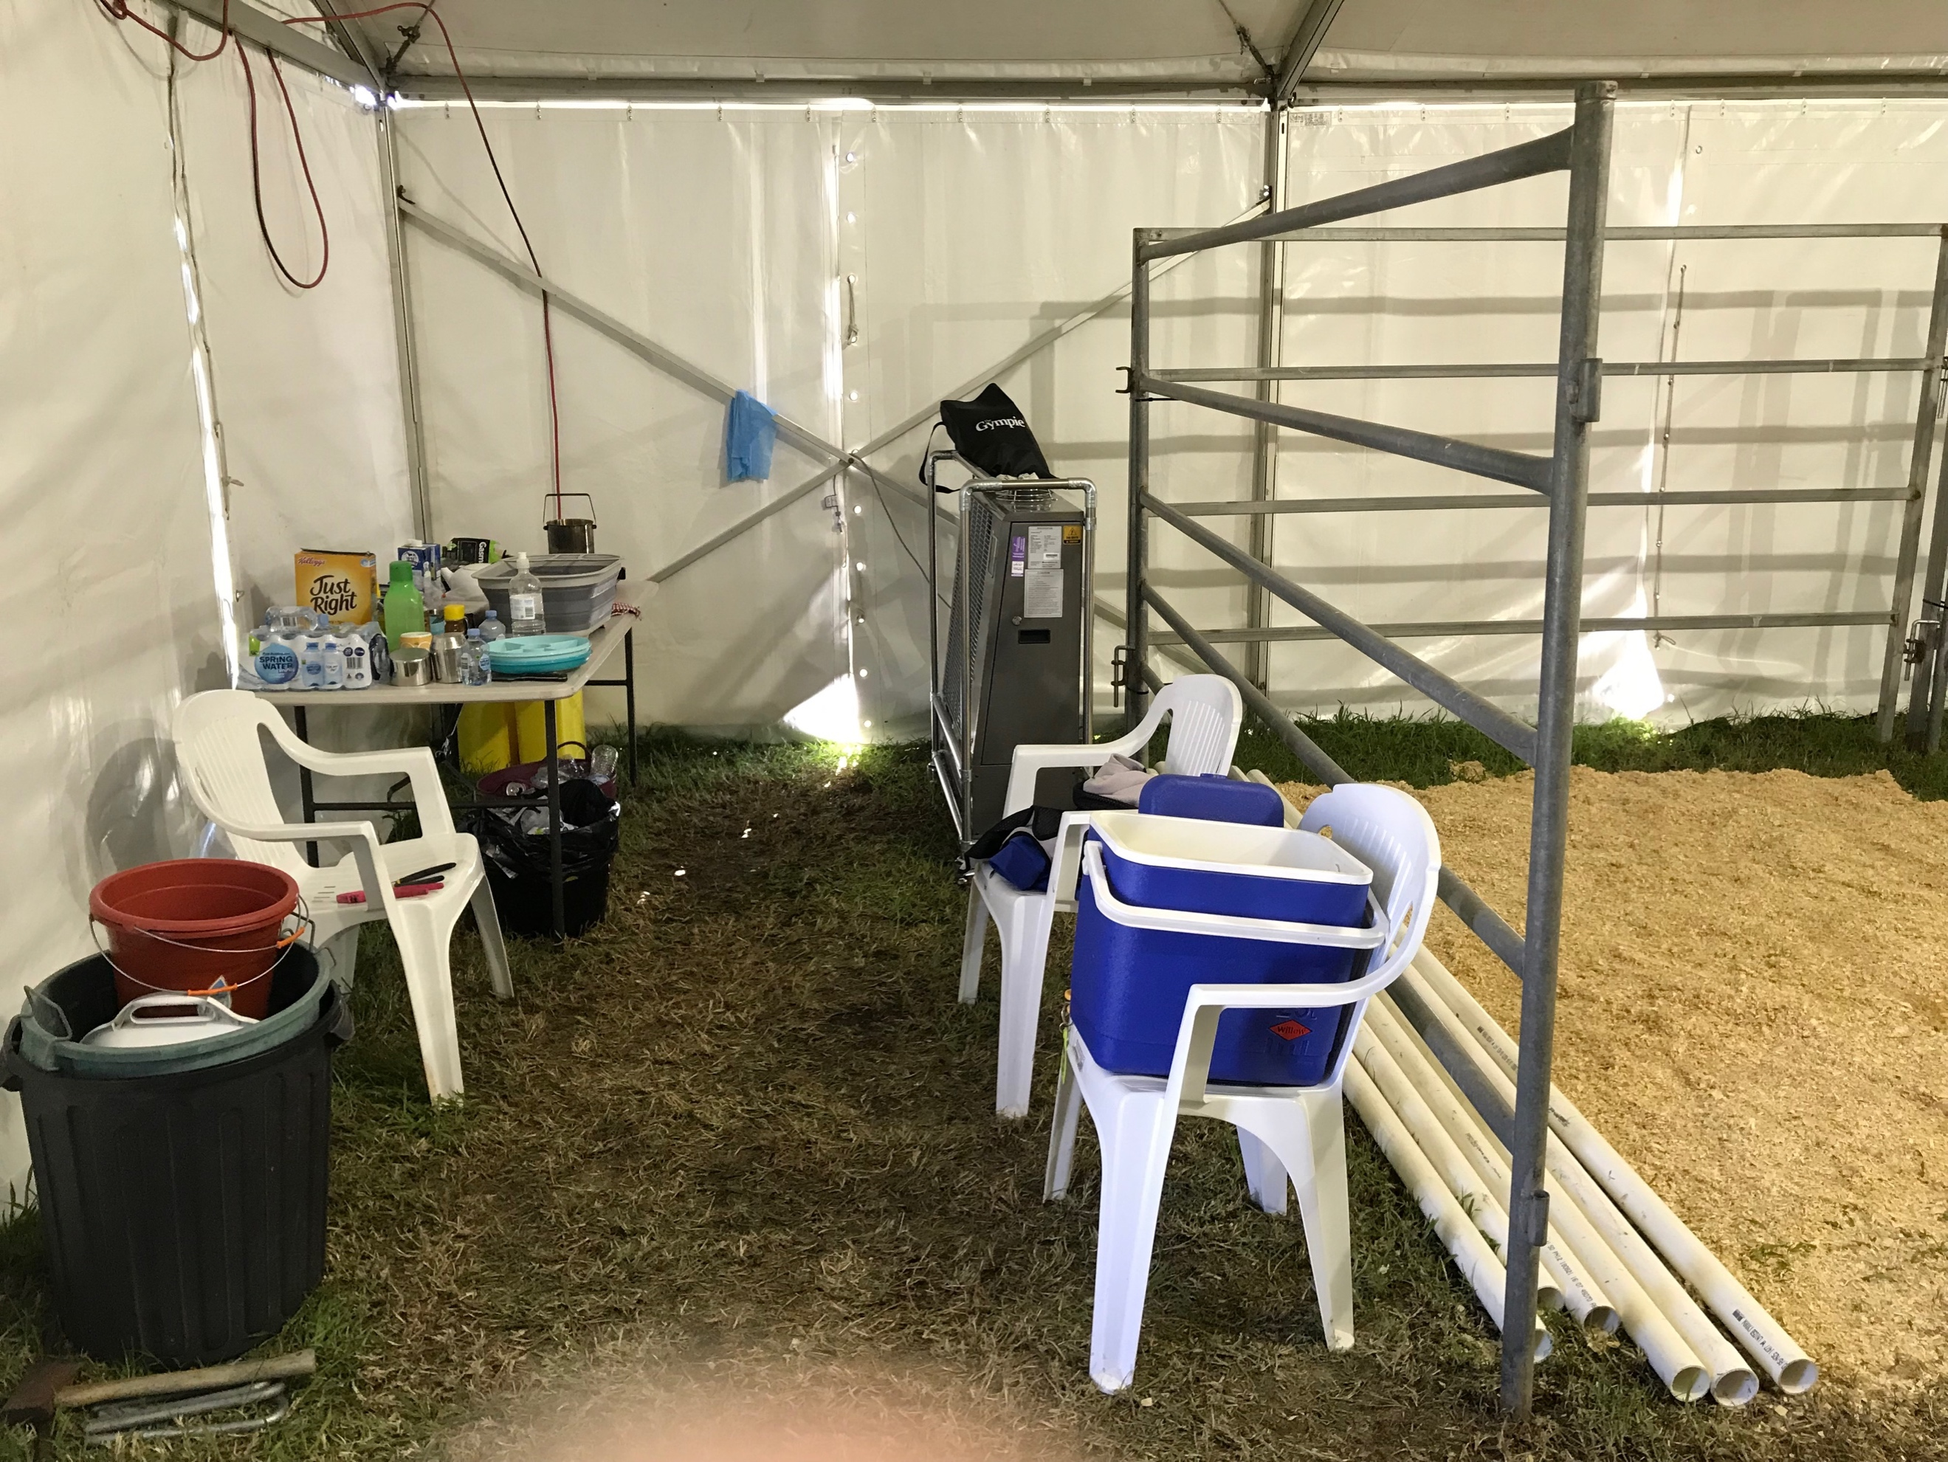

Horse Hospital Sponsorship $5,000

Strapping Area Sponsorship

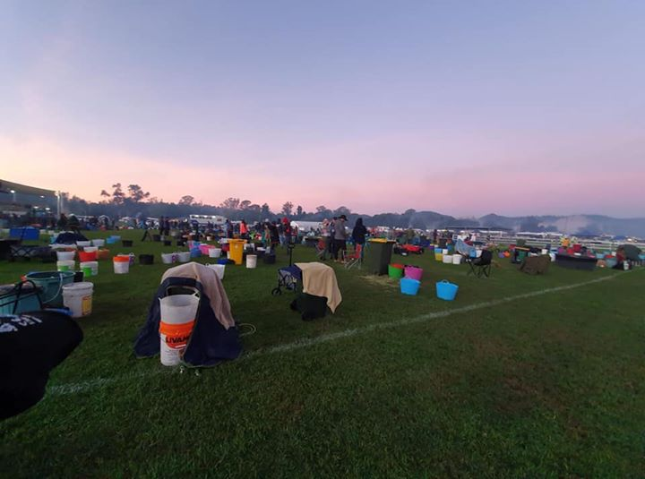
The Strapping Area of the 2020 Tom Quilty Gold Cup is the focal point of the event and will boast a hive of activity throughout the event. The Strapping Area is where riders will return from their loop to rapidly cool their horses prior to the vet examination. Their ride time does not stop until the horse is presented to the veterinary panel and is therefore presents an exciting and vibrant spectacle. The Strapping Area also provides the best spectator viewing and will be frequented by all competitors and their support crew. The Strapping Area will be used six times per horse during the 160km event. Because it is such a large area (approximately 150m²) it allows ample opportunity for sponsor promotional material to be displayed.
- Branding of sponsor name on 6 x 500L water tubs located in strapping site.
- Banners with your organization’s name displayed in the strapping site (if provided).
- Regular announcements broadcast on PA system referring to this named area i.e. Star Express Strapping Site.
- A display in the entertainment and catering area during the event to provide information about your organization, products and/or services.
- Extensive promotion on Tom Quilty Gold Cup website.
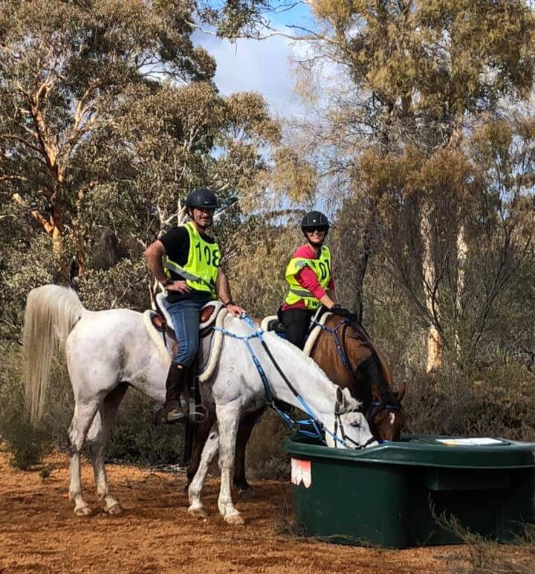
- Free half page colour advertisement in the Tom Quilty Gold Cup Magazine/Endurance Yearbook.
- Sponsor slogan and short paragraph description to be broadcast over the PA system at regular intervals during the event.
- Free entry for 2 sponsor representatives to attend the Quilty Lunch and presentations on Sunday 20 September, 2020.
- 2 Tom Quilty Gold Cup Magazines/Endurance Yearbooks.
- Sponsor acknowledgement at pre-ride briefing and at all presentations.
- Sponsor products, promotional material and information to be distributed to all riders, volunteers, vets, officials and spectators (if provided).

Strapping Area Sponsorship $5,000

“Let There Be Light” Sponsorship

The Tom Quilty Gold Cup traditionally starts at midnight on Friday and concludes at midnight 24 hours later. As such, adequate lighting is essential for riders to prepare horses and for officials and vets to complete their roles .6 lighting towers will be required for the duration of the event. Lighting towers will be provided to the strapping area where riders and grooms will tend to their horses after they have completed a loop. Horses will then proceed to the vetting area, which also requires light for vets to make their assessments. Lighting towers will also be installed in the camping areas to ensure safety throughout the event. The sponsor of this package will have their organisation’s logo prominently displayed throughout the venue.
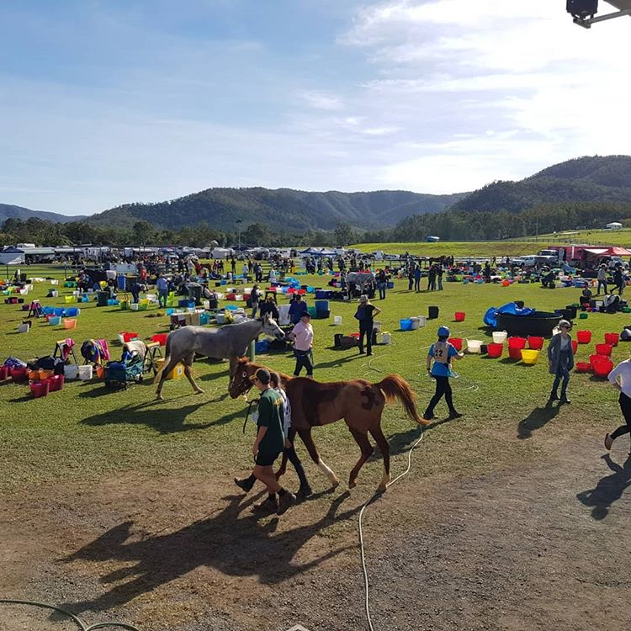
- A display in the entertainment and catering area during the event to provide information about your organisation, products and/or services.
- Extensive promotion on Tom Quilty Gold Cup Website and Facebook page.
- Free half-page colour advertisement within the Tom Quilty Gold Cup Event magazine/Endurance Yearbook.
- Sponsor slogan and short paragraph description to be broadcast over the PA system at regular intervals during the event.
- Free entry for 2 sponsor representatives to attend the Quilty Lunch and Presentations after the event.
- 2 Tom Quilty Gold Cup Event magazines/Endurance Yearbook.
- Sponsorship acknowledgement at Pre-ride Briefing and at all presentations.
- Sponsors products, promotion material, and information to be distributed to all riders, volunteers, vets, officials and spectators (if provided).

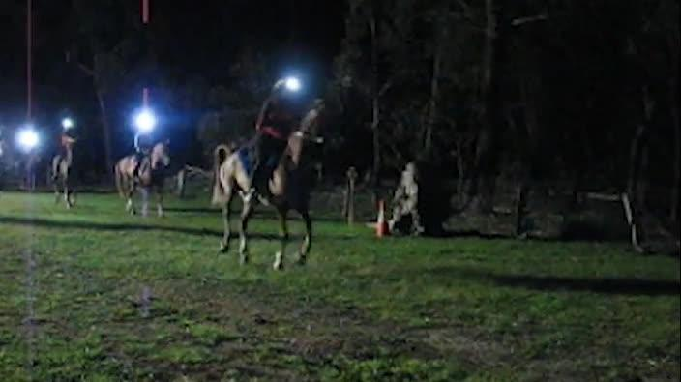

“Let There Be Light” Sponsorship $4,000

Veterinarians & Officials Sponsorship

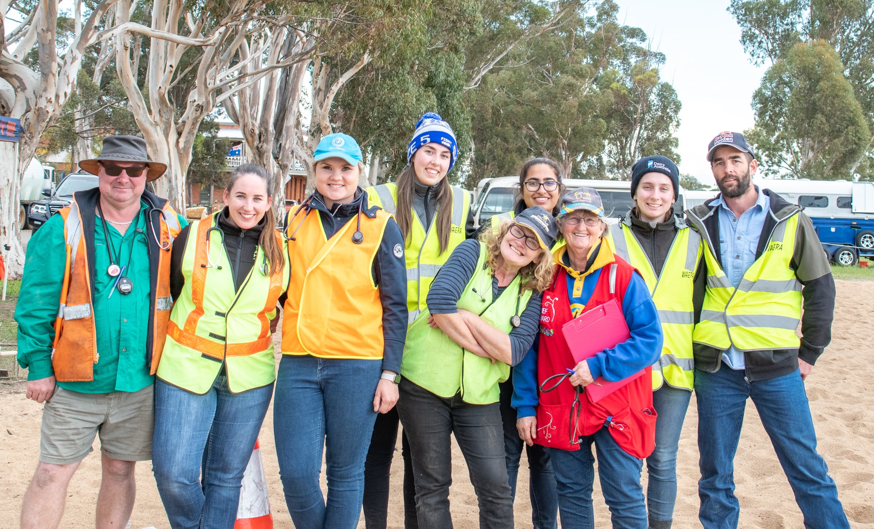
There will be approximately 50 Veterinarian and Officials from WA, Interstate and Overseas actively involved in the smooth and efficient running of this National Championship event. The Vets will be ensuring the welfare of every horse which is paramount amongst Endurance riders. The Vets and Officials will be on duty for over 24 hours from midnight on the Friday night until the very last horse has safely completed the course. There will be an On-Course Vet whose task is to assist any horse whilst on course. There will be a Treatment vet whose job is to treat any horse who becomes injured or unwell. The Vets and the Officials will be the last people to crawl into bed at the completion of the event. Your sponsorship support will help keep all the Vets and Officials fed, hydrated and able to complete their job to the best of their ability. Your sponsorship will also provide a respite marquee for these essential personnel to have a brief rest and recuperate.
- Includes a display in the entertainment and catering area during the event for information about your organisation, products and/or services.
- Your organisation’s logo on advertising and promotion of the event.
- Extensive promotion on Tom Quilty Gold Cup Website and Facebook page.
- Free half-page colour advertisement within the Tom Quilty Gold Cup Event magazine/Endurance Yearbook.
- Sponsor slogan and short paragraph description to be broadcast over the PA system at regular intervals during the event.
- Free entry for 2 sponsor representatives to attend the Quilty Lunch and Presentations after the event
- 2 Tom Quilty Gold Cup Event magazines/Endurance Yearbook.
- Sponsorship acknowledgement at Pre-ride Briefing and at all presentations.
- Sponsors products, promotion material, and information (if provided) to be distributed to all riders, volunteers, vets, officials and spectators

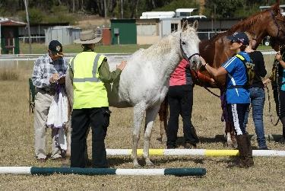

Veterinarians & Officials Sponsorship $2,500

Checkpoint Sponsorships

There will be approximately 6 checkpoints on course for the Tom Quilty Gold Cup event. These checkpoints provide supplies for horses (including water and feed) and refreshments for riders. They are responsible for checking the rider’s status during the event and relaying this information to the ride base. Your checkpoint will be named after your organisation and will be referred to as this on all two-way communications and PA system throughout the event.

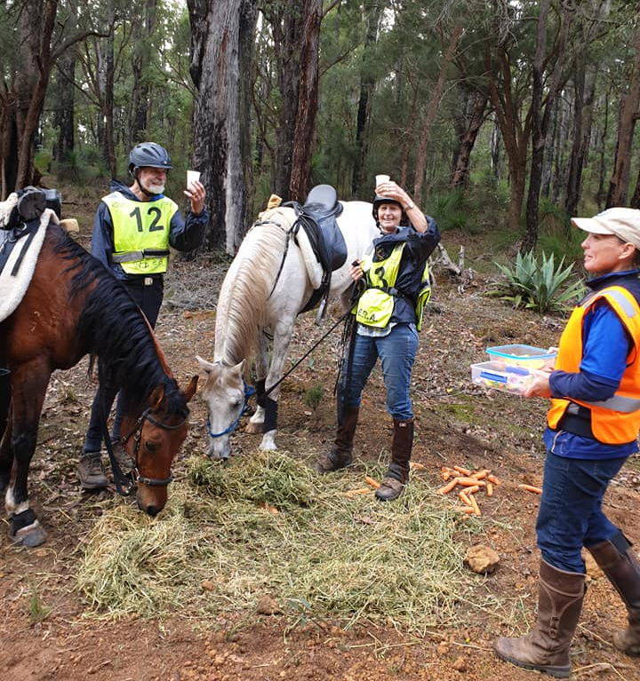
- Banners with your organisation’s name displayed at the checkpoint (if provided).
- Includes a display in the entertainment and catering area during the event for information about your organisation, products and/or services.
- Promotion on Tom Quilty Gold Cup Website and Facebook page.
- Free entry for 1 sponsor representatives to attend the Quilty Lunch and Presentations after the event.
- 1 Tom Quilty Gold Cup Event magazines/Endurance Yearbook.
- Sponsorship acknowledgement at Pre-ride Briefing and at all presentations.
- Sponsors products, promotion material, and information to be distributed to all riders, volunteers, vets, officials and spectators (if provided).

Checkpoint Sponsorships $1,000

Road Crossing Personnel Sponsorship

Safety is a main priority at the Tom Quilty Gold Cup event. Qualified personnel are required to man road crossings to ensure that riders and horses cross safely. The sponsor will receive recognition over the PA system, promotion on the event website, Facebook and the Yearbook.
- Includes a display in the entertainment and catering area during the event for information about your organisation, products and/or services.
- Your organisation’s logo on advertising and promotion of the event.
- Promotion on Tom Quilty Gold Cup Website and Facebook page.
- Free quarter-page colour advertisement within the Tom Quilty Gold Cup Event magazine/Endurance Yearbook.
- Sponsor slogan and short paragraph description to be broadcast over the PA system at regular intervals during the event.
- Free entry for 1 sponsor representative to attend the Quilty Lunch and Presentations after the event.
- 1 Tom Quilty Gold Cup Event magazines/Endurance Yearbook.
- Sponsorship acknowledgement at Pre-ride Briefing and at all presentations.
- Sponsors products, promotion material, and information to be distributed to all riders, volunteers, vets, officials and spectators (if provided).

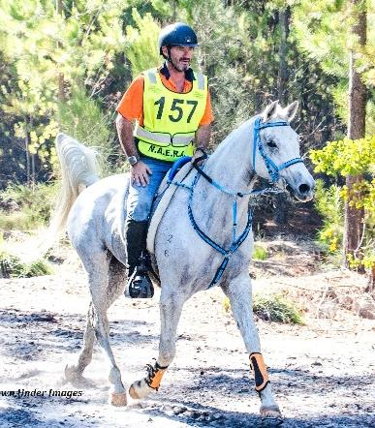

Road Crossing Personnel Sponsorship $700

1st Place Prize Sponsorship

There will be four divisions (based on age and weight) that riders will be competing under. The top five in each division (Heavyweight, Middleweight, Lightweight, and Junior) will receive a prize. The sponsor of the first-place prize in each division will receive publicity and exposure before, during and after the event to thank them for their generous sponsorship.
- If sponsors are present at the presentation on Sunday, 19 September 2020, they will be invited to present their sponsored award.
- Your organisation’s logo on advertising and promotion of the event.
- Promotion on Tom Quilty Gold Cup Website and Facebook page.
- Sponsor organisation or individual’s name embroidered on a rug presented to winners in each division.
- A Quilty Buckle on a handmade wooden stand complete with a plaque engraved with sponsor’s name.
- Free half-page colour advertisement within the Tom Quilty Gold Cup Event magazine/Endurance Yearbook.
- Sponsor slogan and short paragraph description to be broadcast over the PA system at regular intervals during the event.
- Free entry for 1 sponsor representative to attend the Quilty Lunch and Presentations after the event.
- 1 Tom Quilty Gold Cup Event magazines/Endurance Yearbook.

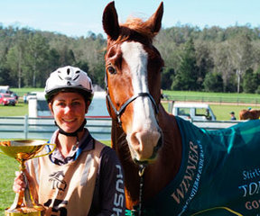

Sponsorship Sold

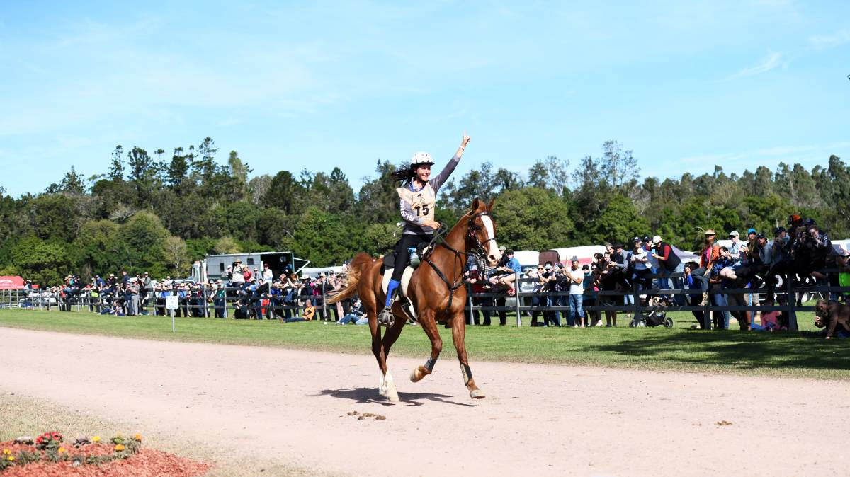

1st Place Prize Sponsorship $1250 (per division)

2nd Place Prize Sponsorship

There will be four divisions (based on age and weight) that riders will be competing under. The top five in each division (Heavyweight, Middleweight, Lightweight, and Junior) will receive a prize. The sponsor of the second-place prize in each division will receive publicity and exposure before, during and after the event to thank them for their generous sponsorship.
- If sponsors are present at the presentation on Sunday, 19 September 2020, they will be invited to present their sponsored award.
- Your organisation’s logo on advertising and promotion of the event.
- Promotion on Tom Quilty Gold Cup Website and Facebook page.
- Sponsor organisation or individual’s name embroidered on a rug presented to second-place getter in each division.
- A Quilty Buckle on a handmade wooden stand complete with a plaque engraved with sponsor’s name.
- Free quarter-page colour advertisement within the Tom Quilty Gold Cup Event magazine/Endurance Yearbook.
- Sponsor slogan and short paragraph description to be broadcast over the PA system at regular intervals during the event.
- 1 Tom Quilty Gold Cup Event magazines/Endurance Yearbook.
- Free entry for 1 sponsor representative to attend the Quilty Lunch and Presentations after the event.

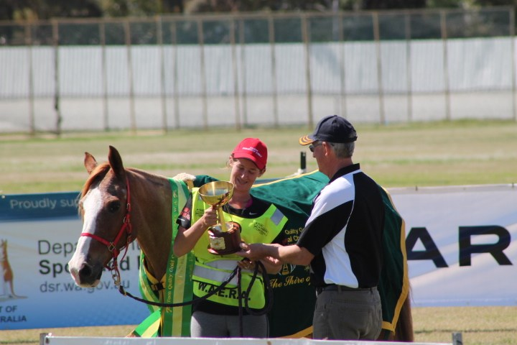

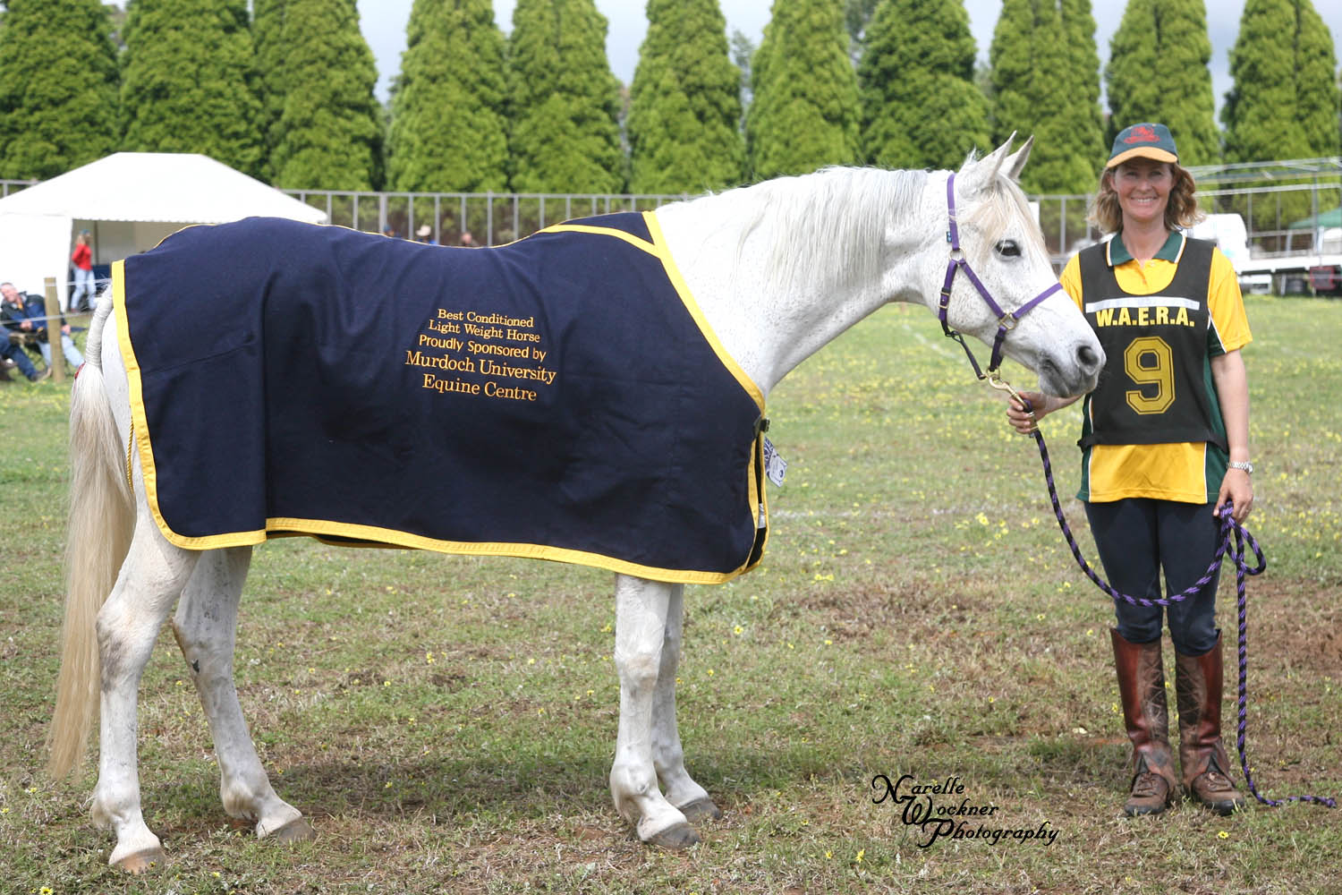

2nd Place Prize Sponsorship $1000 (per division)

3rd Place Prize Sponsorship

There will be four divisions (based on age and weight) that riders will be competing under. The top five in each division (Heavyweight, Middleweight, Lightweight, and Junior) will receive a prize. The sponsor of the third-place prize in each division will receive publicity and exposure before, during and after the event to thank them for their generous sponsorship.
- If sponsors are present at the presentation on Sunday, 19 September 2020, they will be invited to present their sponsored award.
- Your organisation’s logo on advertising and promotion of the event.
- Promotion on Tom Quilty Gold Cup Website and Facebook page.
- Sponsor organisation or individual’s name embroidered on a rug presented to third-place getter in each division.
- A Quilty Buckle on a handmade wooden stand complete with a plaque engraved with sponsor’s name.
- Free quarter-page colour advertisement within the Tom Quilty Gold Cup Event magazine/Endurance Yearbook.
- Sponsor slogan and short paragraph description to be broadcast over the PA system at regular intervals during the event.
- 1 Tom Quilty Gold Cup Event magazines/Endurance Yearbook.

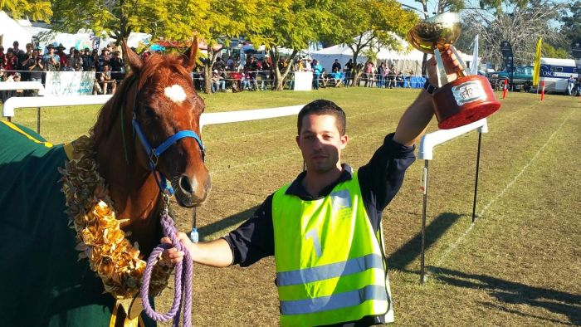

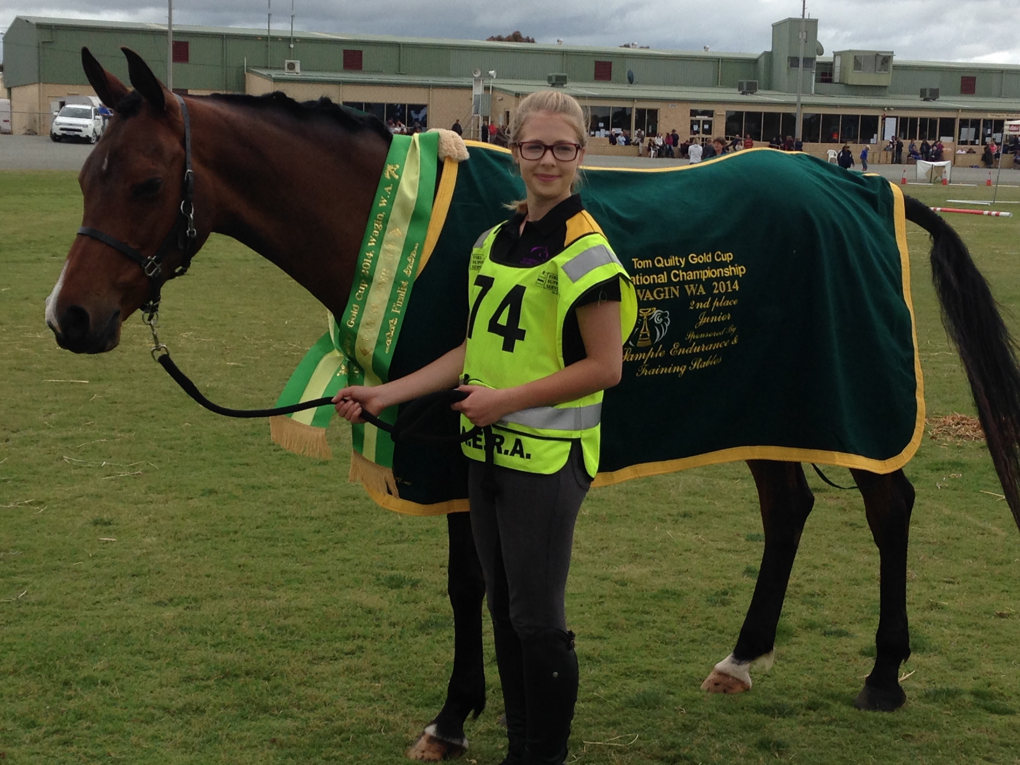

3rd Place Prize Sponsorship $750 (per division)

5th Place Prize Sponsorship

There will be four divisions (based on age and weight) that riders will be competing under. The top five in each division (Heavyweight, Middleweight, Lightweight, and Junior) will receive a prize. The sponsor of the fifth-place prize in each division will receive publicity and exposure before, during and after the event to thank them for their generous sponsorship.
- If sponsors are present at the presentation on Sunday, 19 September 2020, they will be invited to present their sponsored award.
- Your organisation’s logo on advertising and promotion of the event.
- Promotion on Tom Quilty Gold Cup Website and Facebook page.
- Sponsor organisation or individual’s name embroidered on a rug presented to fifth-place getter in each division.
- Free quarter-page colour advertisement within the Tom Quilty Gold Cup Event magazine/Endurance Yearbook.
- Sponsor slogan and short paragraph description to be broadcast over the PA system at regular intervals during the event.
- 1 Tom Quilty Gold Cup Event magazines/Endurance Yearbook.

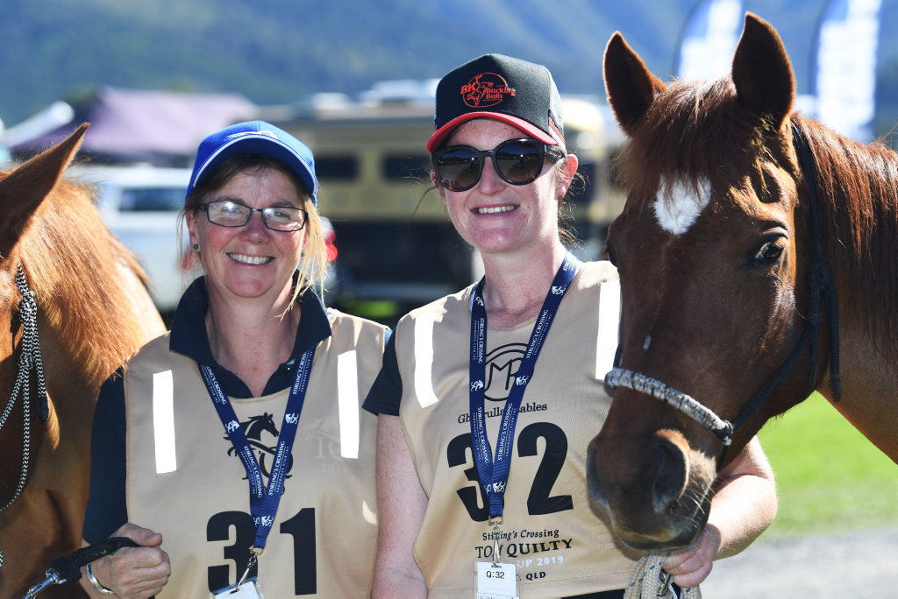

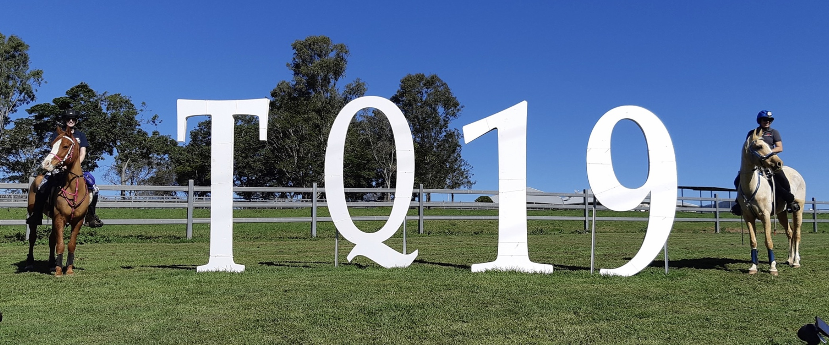

5th Place Prize Sponsorship $500 (per division)

Quilty Buckle Sponsorship

The Quilty Buckle is the coveted prize awarded for successful completion of the Tom Quilty Gold Cup event. It epitomises the motto of endurance riding: “To complete is to win”. Sponsoring a buckle is a great way for individuals and small businesses to support the event and contribute to a memento that will be cherished by the recipient for life.

- You and/or your organisation will be acknowledged on an engraved plaque on the wooden display stand that holds the Quilty Buckle.
- Your name and/or organisation’s name will be listed as a buckle sponsor in the Tom Quilty Gold Cup Event magazine/Endurance Yearbook.

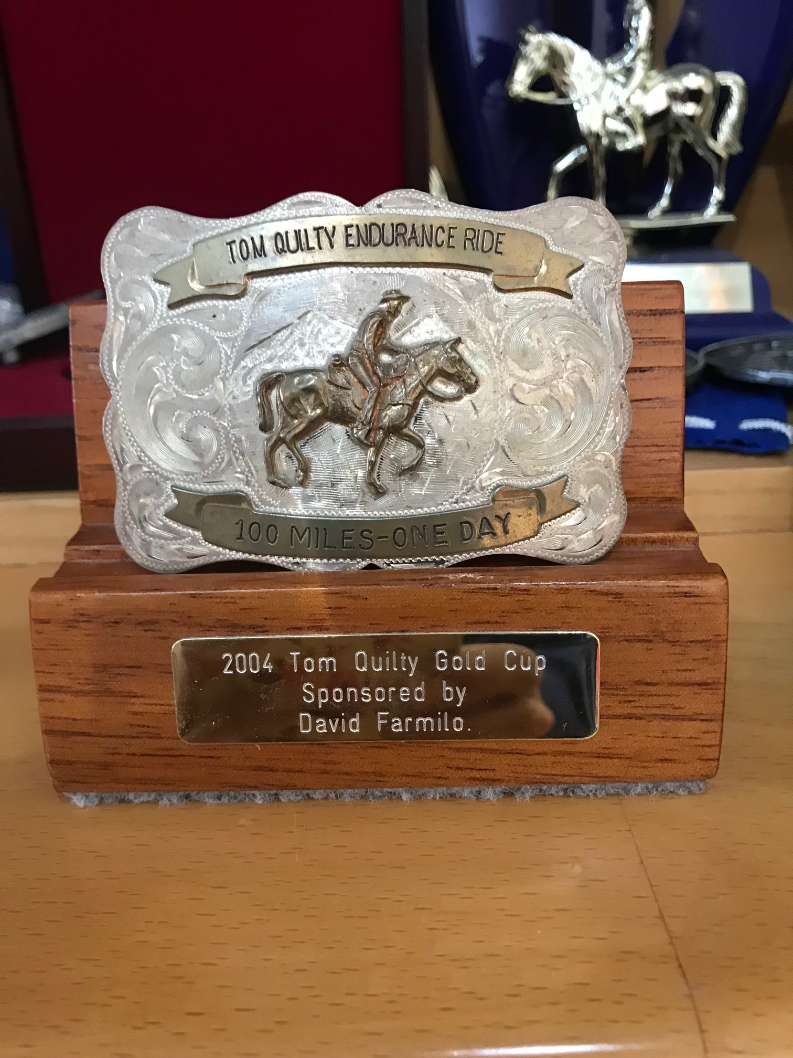

Quilty Buckle Sponsorship $350

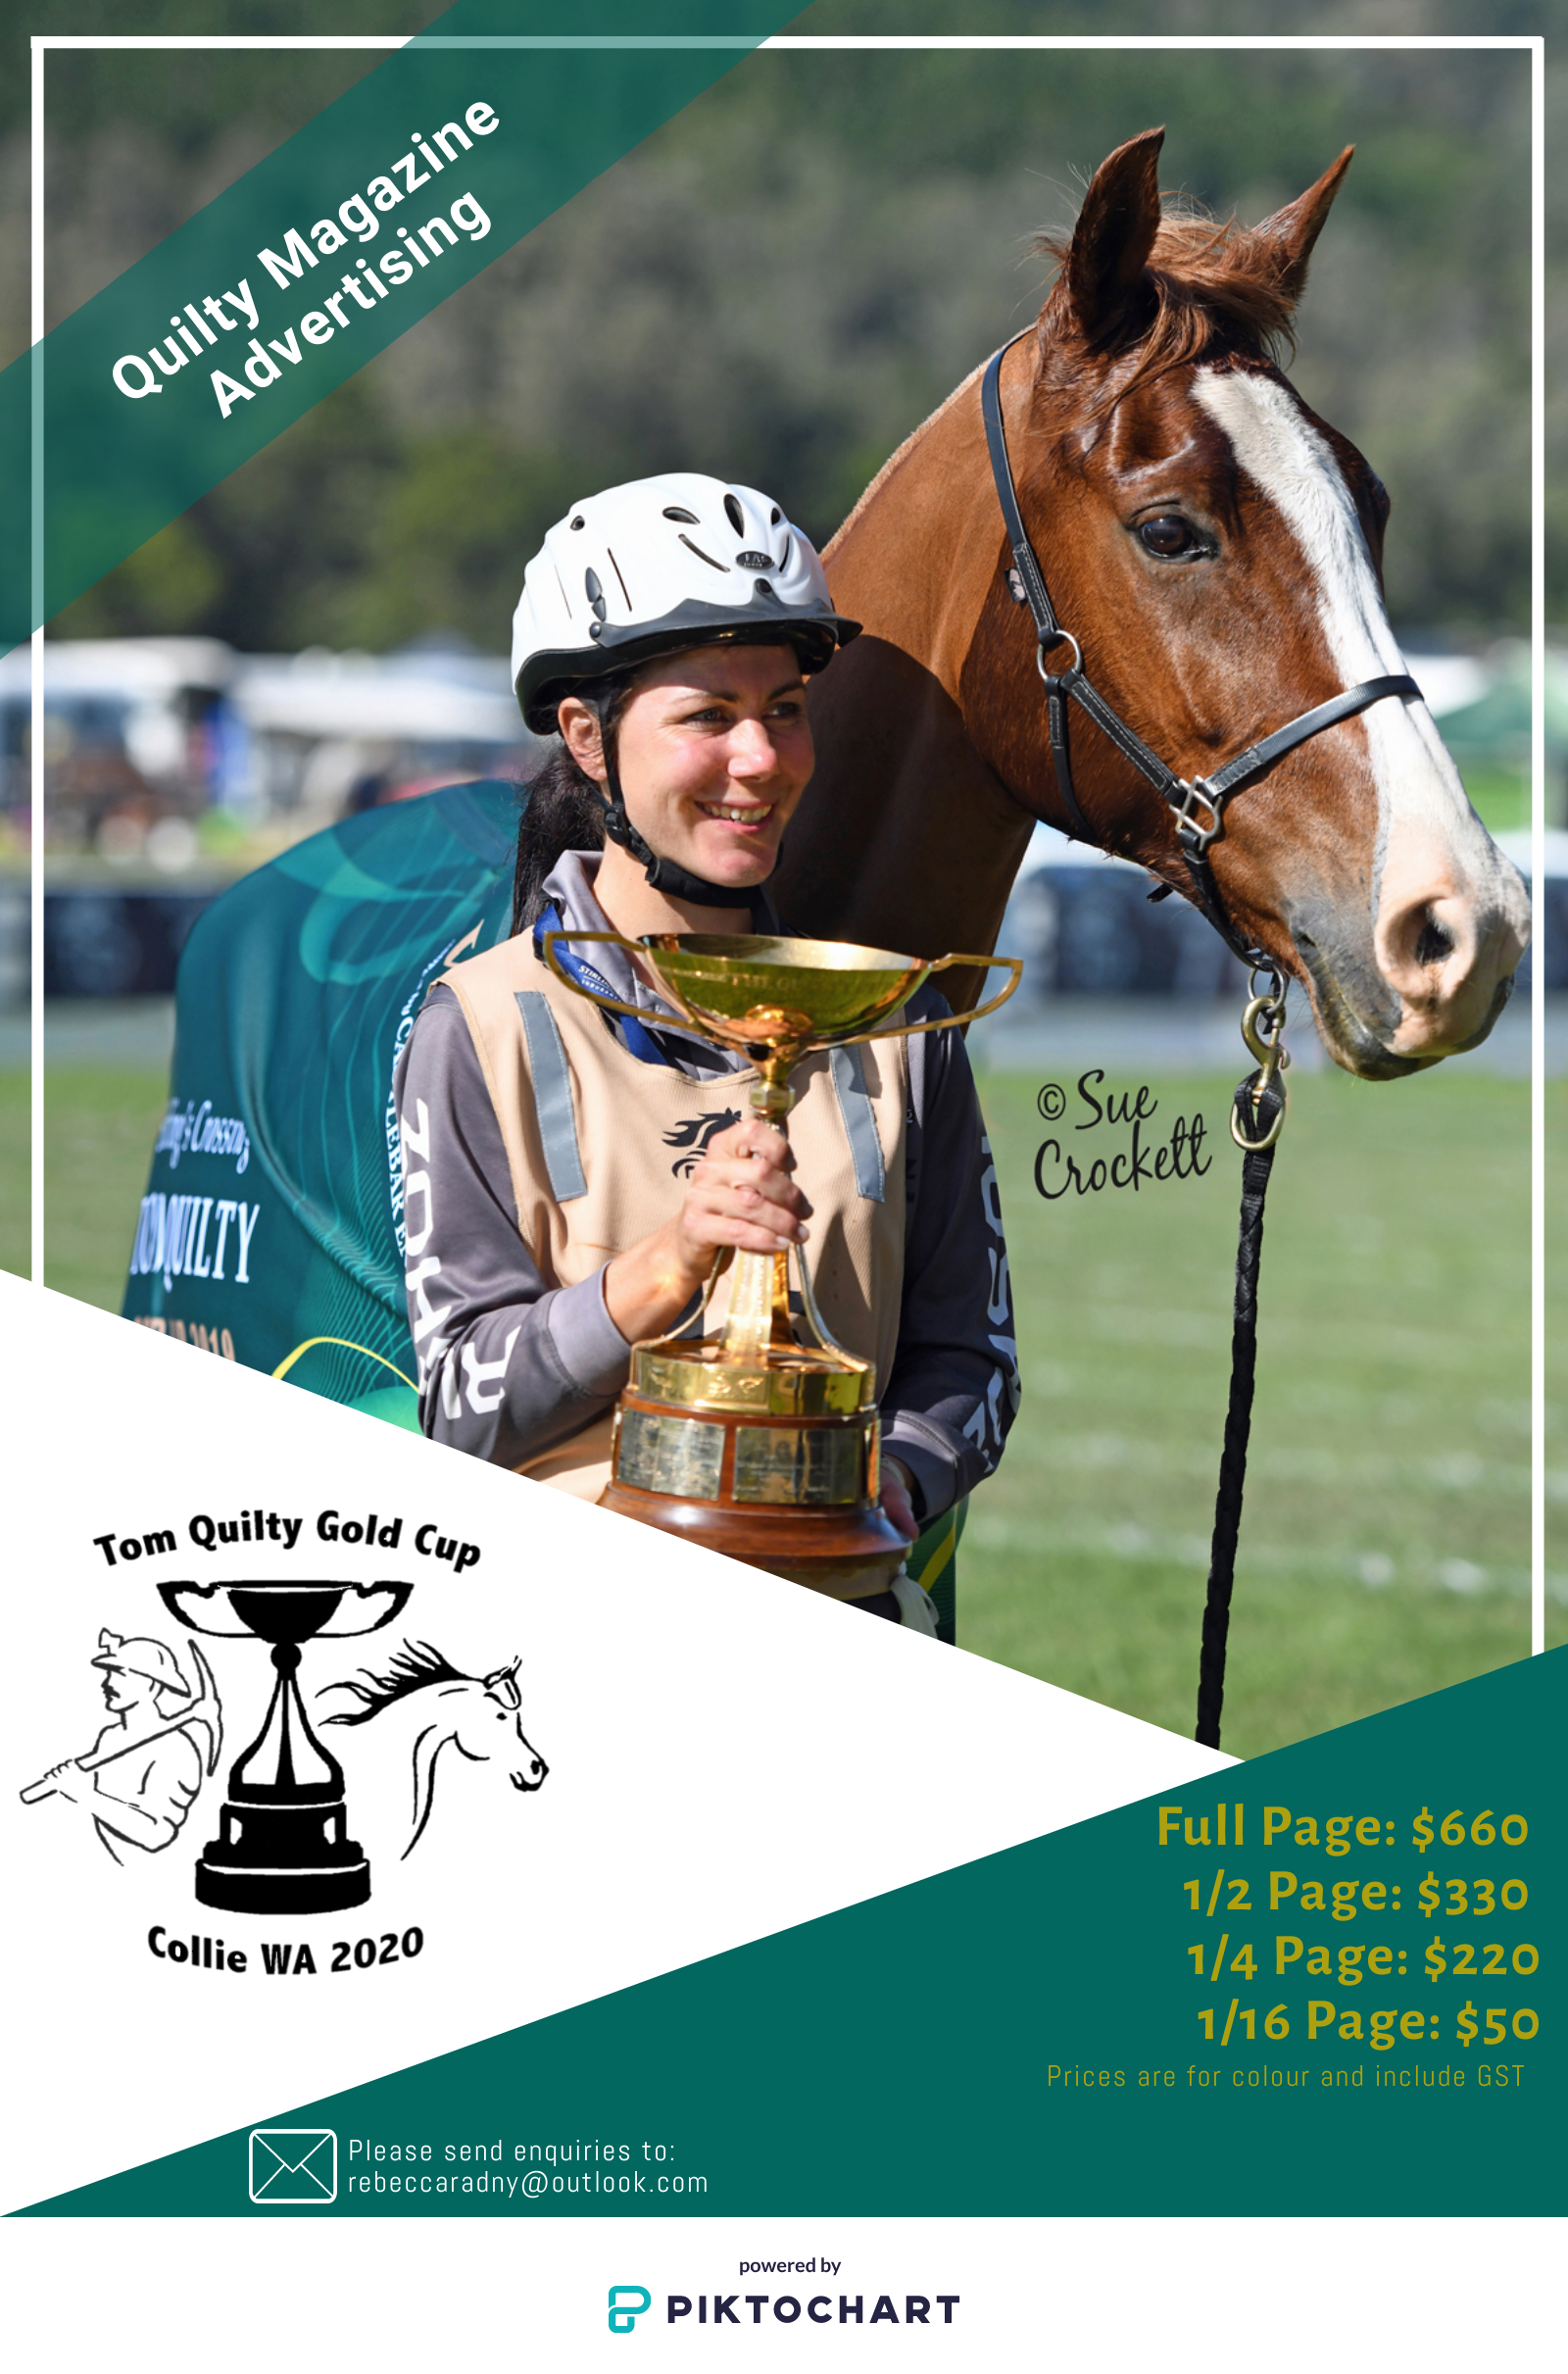

Product Endorsements

The 2020 Tom Quilty Gold Cup Organising Committee will be happy to accept products that can be distributed to riders as prizes and/or to all riders, volunteers and/or officials. Your support can be individually tailored with the sponsorship team.
Examples include: brochures, gift vouchers, and product samples.

Trade Stalls

Trade Stalls will be set up in the Entertainment & Catering Area. Information about your business, products and/or services can be displayed and sold. This is a complementary service. Businesses will need to provide their own marquee, power (if required) and display equipment.
Please contact us for more information on trade stalls.

We can tailor any of the above sponsorship packages to cater for your needs and welcome discussion how we can best promote your organisation at our event.
Kind regards,
Sponsorship Portfolio Team – 2020 Tom Quilty Gold Cup, Collie, WA

Direct deposit details:
Account Name: WAERA TQ2020
BSB: 633 000
Account number: 164 458 325

Photo credits: Down Under Images, Tracey Lynn, Denise Kleenan, Kevin Coppalotti, Sue Crockett, Narelle Wockner

